 | 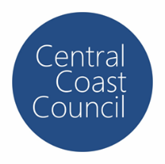
COUNCIL ASSESSMENT REPORT
HUNTER AND CENTRAL COAST REGIONAL PLANNING PANEL

PANEL REFERENCE & DA NUMBER | PPSHCC-96-Central Coast  DA/1276/2021 (PAN-144863)
PROPOSAL | Proposed Alterations and Additions including Demolition and Change of Use of an Existing Aged Care Facility to a Community Facility.
ADDRESS | Lot 1 Sec 1 DP 3368, 35 McPherson Road, Mardi
APPLICANT | ADW Johnson
OWNER | Yerin Aboriginal Health Services Limited
DA LODGEMENT DATE | 21 September 2021
APPLICATION TYPE | Integrated Development Application – Water Management Act 2000 (Office Water) with a Capital Investment Value >$5 million
REGIONALLY SIGNIFICANT CRITERIA | Section 5(b), Schedule 6 of the Planning Systems SEPP 2021
CIV | $8,231,000 (excluding GST)
CLAUSE 4.6 REQUESTS | N/A
KEY SEPP/LEP | - State Environmental Planning Policy (Planning Systems) 2021  - State Environmental Planning Policy (Resilience and Hazards) 2021  - State Environmental Planning Policy (Transport and Infrastructure) 2021  - Wyong Local Environmental Plan 2013  - Central Coast Local Environmental Plan 2022  - Wyong Development Control Plan 2013  - Chapter 1.2 – Notification of Development Proposals  - Chapter 2.11 – Parking and Access  - Chapter 3.1 – Site Waste Management  - Chapter 3.3 – Floodplain Management  - Draft State Environmental Planning Policy Environment (SEPP Environment)  - Draft Remediation of Land SEPP;
TOTAL & UNIQUE SUBMISSIONS KEY ISSUES IN SUBMISSIONS | One submission raising no objections to the development received from the NSW Department of Planning, Industry and Environment – Crown Lands.
DOCUMENTS SUBMITTED FOR CONSIDERATION | Council Assessment Report and Attachments A- G  A – Draft Conditions - D15621052  B – Landowner’s Consent - D15620222  C – Architectural Plans - D15089775  D – Plan of Management - D14985938  E – Flood Assessment Report - D14843529  F – Flood Emergency Response Plan - D14843528  G – DPE General Terms of Approval - D15513355
SPECIAL INFRASTRUCTURE CONTRIBUTIONS (S7.24) | N/A
RECOMMENDATION | Deferred Commencement Consent
DRAFT CONDITIONS TO APPLICANT | YES
SCHEDULED MEETING DATE | 12 April 2023
PLAN VERSION | 21 March 2022 Version B-F
PREPARED BY | Nathan Burr – Central Coast Council
DATE OF REPORT | 5 April 2023

EXECUTIVE SUMMARY

The development application is for Alterations and Additions and Change of Use of an Existing Aged Care Facility to a Community Facility.
The subject site is commonly known as 35 McPherson Road, Mardi NSW 2259 and is legally described as Lot 1 Sec 1 DP3386. The site is located on the northern side of McPherson Road adjacent to the banks of Wyong River. The site contains a vacant Aged Care Facility which had operated on the site since at least the 1960’s.
The land is zoned C3 – Environmental Management under Wyong Local Environmental Plan 2013 (WLEP 2013). Portions of the existing building and its curtilage and areas of the existing parking and access encroach onto the neighbouring Crown Reserve which is zoned RE1 – Public Recreation under that instrument.
The proposed works include the following:
- Minor internal and external demolition works;
- A new external access ramp and stairs;
  - Internal modifications to create the floor space and rooms required for the community facility to accommodate its clients and staff:- Reception Hub, Triage Room; Waiting Areas, Gym, Consult, Group Consult, and Treatment Rooms;
  - Women’s Health / Child and Family Room, and Children’s Area;
  - Offices, Meeting and Interview Rooms, and Multi-Purpose/Function room for Yerin Staff;
- New sanitary facilities including ambulant and disabled sanitary facilities; and
- A new permeable car parking area at the front of the site to provide additional parking to cater for the community facility.
General Terms of Approval have been received from the NSW Department of Planning and Environment with respect to a controlled activity under section 91 of the Water Management Act 2000.
Jurisdictional prerequisites to the grant of consent imposed by the following controls have been satisfied including:

- Sections 2.10 and 2.11 of State Environmental Planning Policy (Resilience and Hazards) 2021 for consideration of impacts on th coastal use and coastl environment areas;
- Sections 4.6 of State Environmental Planning Policy (Resilience and Hazards) 2021 for consideration of whether the land is contaminated;
- Clauses 2.3, 5.21, 7.1 and 7.9 of Wyong Local Environmental Plan 2013 with respect to the permissibility of the development, flooding impacts, acid sulfate soils and essential services

The development was publicly notified in accordance with chapter 1.2 of Wyong Development Control Plan 2013 from 8 October 2021 to November 2021 with one submission being received from the NSW Department of Planning, Industry and Environment – Crown Lands who is an adjoining owner raising no objections to the development.

Briefings were held with the Panel in November 2021, March 2022, August 2022 and February 2023 wherein the following key issues were identified.

- Permissibility – Legal advice has been obtained that demonstrates the development may be appropriately characterised as a community facility which is permissible with consent.
- Flooding - Despite the flood affectation, the proposed development can be supported due to the significant reduction in flood risk and significant reduction in time that there are people on site. The proposed Flood Emergency Plan is expected to further mitigate the Flood Risk compared to the historic use of the site.
- Traffic – A Traffic Impact Statement was submitted detailing the existing road conditions and the anticipated traffic generation associated with the development with no significant impacts identified.
- Landowner’s Consent – The existing development encroaches onto the adjoining land that is a Crown Reserve. Appropriate landowner’s consent was not submitted with the application and had to be obtained. The Reserve is the subject of a land title claim which restricted the ability for the Department to issue landowner’s consent however, landowner’s consent has been obtained.

The development has been found to be on balance in keeping with the public interest and an over reduction in the flood risk in comparison to the historic use of the site and following a detailed assessment of the proposal, pursuant to Section 4.16(1)(b) of the EP&A Act, DA 1276/2021 is recommended for approval subject to the conditions contained at Attachment A of this report.

- THE SITE AND LOCALITY

  - The Site

The subject site is commonly known as 35 McPherson Road, Mardi NSW 2259 and is legally described as Lot 1 Sec 1 DP3386. The site is located on the northern side of McPherson Road adjacent to the banks of Wyong River. The site contains a vacant Aged Care Facility which had operated on the site since at least the 1960’s.

The site is accessed via McPherson Road which connects the Pacific Highway (via South Tacoma Road) and Old Maitland Road. Ground levels at the site are approximately RL 2.9 AHD and the 1% AEP flood level is approximately RL 4.54m AHD. The site is identified as being flood prone land with the portions of the site that do not contain the existing building being identified as floodway.

The land is zoned C3 – Environmental Management under Wyong Local Environmental Plan 2013 (WLEP 2013). Portions of the existing building and its curtilage and areas of the existing parking and access encroach onto the neighbouring Crown Reserve which is zoned RE1 – Public Recreation under that instrument.

WLEP 2013 has since been repealed and replaced with Central Coast Local Environmental Plan 2022 (CCLEP 2022) which retains the C3 and RE1 zones. The development application is captured by the Savings Provisions contained within clause 1.8A of CCLEP 2022.

There are no standards relating to the height of buildings or floor space ratio applicable to the site or adjoining reserve under WLEP 2013 however, the site is subject to a minimum lot size of 40Ha. The site is not within a Heritage Conservation Area, is not identified as a Heritage Item, is not subject to a foreshore building line, and is not within the drinking water catchment.

The site is not bushfire prone but is identified as containing class 3 and class 4 actual or potential acid sulphate soils. There are existing connections to reticulated services including a 100mm water main and 150mm gravity sewer main. The site is within the NSW Coastal Environment and Coastal Use areas as identified in Chapter 2 Coastal Management of State Environmental Planning Policy (Resilience and Hazards) 2021.

Figure 1: Site (outlined in blue) and Surrounds

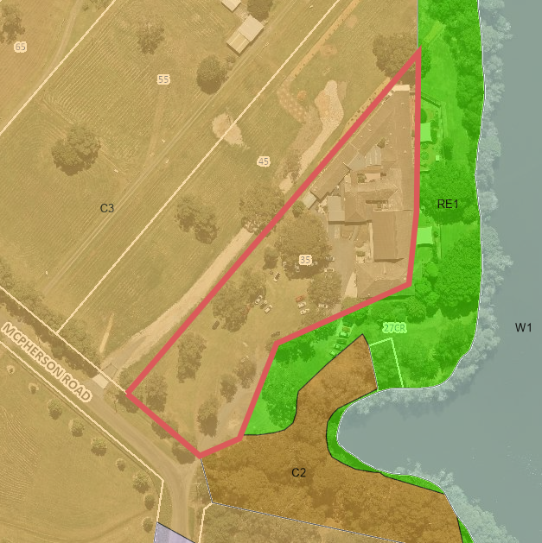
Figure 2: WLEP 2013 Zone Map

  - The Locality

The site is located within a flood prone corridor adjacent to the Wyong River and nearby development is reflective of the flooding constraint, being largely comprised of small rural holdings containing dwellings and associated outbuildings, in addition to public lands forming the banks of the river.

The southern edges of the Wyong Town Centre are located on the opposite side of the river however, the natural topography and existing vegetation visually separates the site from the Wyong Township. South of the site is the Tuggerah straight commercial and industrial precinct, which is an intensively developed area comprising a range of uses including car sales yards, large retail, light industrial and fast-food premises.

Like the Wyong Township, the site is buffered from the employment lands by topography, flood constrained land and vegetation. The locality is depicted on the aerial photo below.

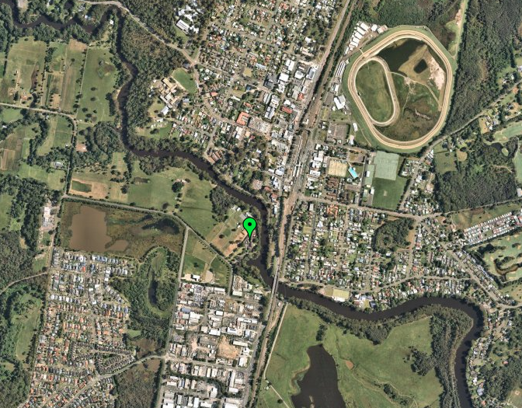
Figure 3: Wyong Township top of photo through to Tuggerah Straight bottom photo, green pin signifies the subject site.

- THE PROPOSAL AND BACKGROUND

  - The Proposal

The proposal seeks consent for alterations and additions in association with the change of use of an existing Aged Care Facility to a Community Facility.

The Statement of Environmental Effects (SEE) submitted with the development application describes the proposed works as comprising the following:

- Minor internal and external demolition works;
- A new external access ramp and stairs;
- Internal modifications to create the floor space and rooms required for the community facility to accommodate its clients and staff:-
  - Reception Hub, Triage Room; Waiting Areas, Gym, Consult, Group Consult, and Treatment Rooms;
  - Women’s Health / Child and Family Room, and Children’s Area;
  - Offices, Meeting and Interview Rooms, and Multi-Purpose/Function room for Yerin Staff;
- New sanitary facilities including ambulant and disabled sanitary facilities; and
- A new permeable car parking area at the front of the site to provide additional parking to cater for the community facility.

The flood report submitted in support of the development application indicates the following works are required:

- The main electrical distributor hub for the building as well as distributor box 1 are located at an approximate level of 5.4 m AHD, which is above the 1% AEP floor level plus free board (0.5 m).
- Where possible, internal walls, fixtures, fittings, furniture and flooring will be made of flood compatible materials.

There are no proposed changes to the exiting gross floor area, building footprint or building height.

The proposed use is described in the SEE as comprising:

- A community hub service providing support through a range of trauma informed programs;
- Appointment space for a number of outreach services;
- Aboriginal Health Service;
- The community facility will enable a one stop shop for Aboriginal and Torres Strait Islander individuals and families and a community connection point;
- Support from other NGOs including Lifeline, Wesley Mission, NDIS Providers, visiting health providers, education, training and other community and government-based services;
- Provide culturally related community activities and forums.

The community facility will operate Monday to Friday, between 9.00am to 5.00pm. Staff will be present during work hours, with staggered rostering from 8.00am to 6.00pm Monday to Friday. 89 staff will be employed at the facility with additional six (6) visiting staff on a weekly or fortnightly basis.

The community facility will offer a number of in-reach and outreach programs. Not all staff will be present on site at any one time due to staggered rostering and delivery of the outreach programs which are off-site.

The proposed site plan and internal plan showing proposed building use are included below.

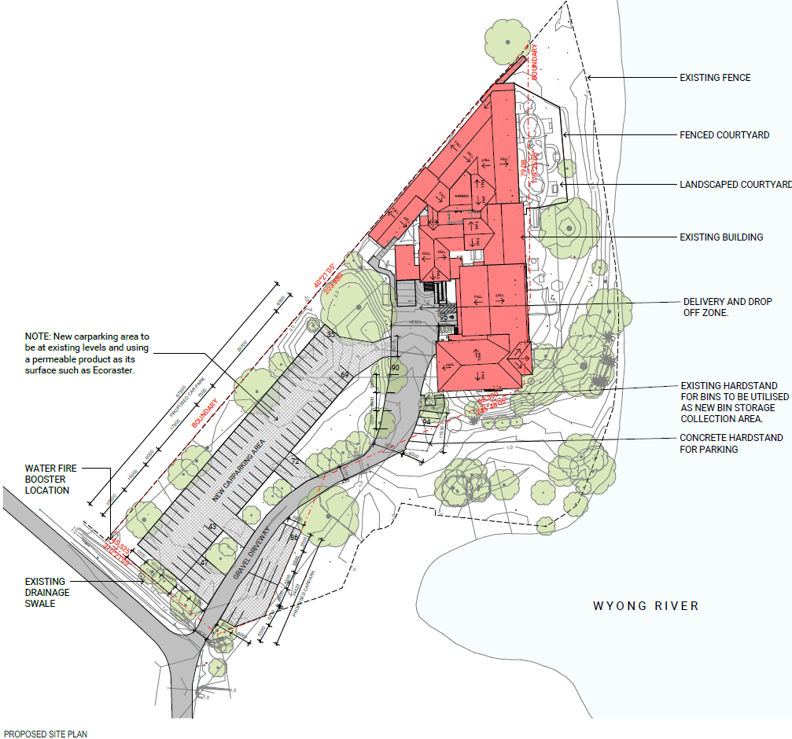
Figure 4 : Proposed Site Plan

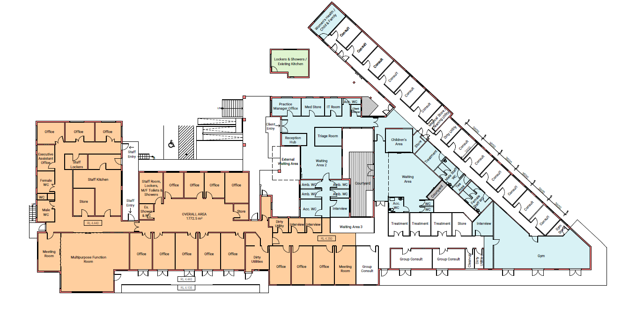
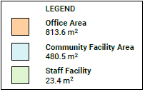
Figure 5: Internal building plan and proposed use

Table 1: Development Data
Control | Proposal
Site area | 0.9Ha
GFA | 1317.5m²
FSR (retail/residential) | 0.146:1
Clause 4.6 Requests | No
No of apartments | -
Max Height | Approximately 8.2m
Landscaped area | Approximately 2414m²
Car Parking spaces | 95 inclusive of existing and proposed spaces
Setbacks | The existing building is located in the north-eastern portion of the site generally filling this part of the site with setbacks ranging from encroachment to approximately 4.5m. The building is approximately 105m from the McPherson Road frontage.

  - Background

A pre-lodgement meeting was held prior to the lodgement of the application on 2 December 2020 where various issues were discussed. The key issues raised are summarised below:

- Permissibility

- Acid Sulphate Soils

- Flood Planning

The development application was lodged on 21 September 2021. A chronology of the development application since lodgement is outlined below including the Panel’s involvement (briefings, deferrals etc) with the application:

Table 2: Chronology of the DA
Date | Event
21 September 2021 | DA lodged
8 October 2021 | Exhibition of the application
1 October 2021 | DA referred to external agencies
3 November 2021 | Panel Briefing
5 November 2021 | Request For Information – Permissibility, Traffic, Waste and Ecology
17 December 2021 | Additional information lodged – Traffic Impact Statement and updated Plan of Management to address Grey-head flying fox.
16 February 2022 | Request for Information – Engineering Details
3 March 2022 | Panel Briefing
21 March 2022 | Additional Information Received – Update plan and Waste Details, Propriety specification for Ecoraster
17 August 2022 | Panel Briefing
2 December 2022 | Landowner’s consent provided
21 February 2023 | Panel Briefing

  - Site History

It is not clear from Council’s records when the facility was originally approved and as a result it is difficult to determine what the existing development was originally approved as. There are notations on file referring to alterations to the facility in 1967 with an application for significant additions for the purposes of surgical rooms being refused in 1972 due to the lack of reticulated sewer being available to the site at that time.

The reticulated sewer service to the site was approved in 1974 and alterations and additions approved by the former Wyong Shire Council in 1982. The relevant applications since the 1990’s are summarised in the table below.

Table 3: Part Approval History
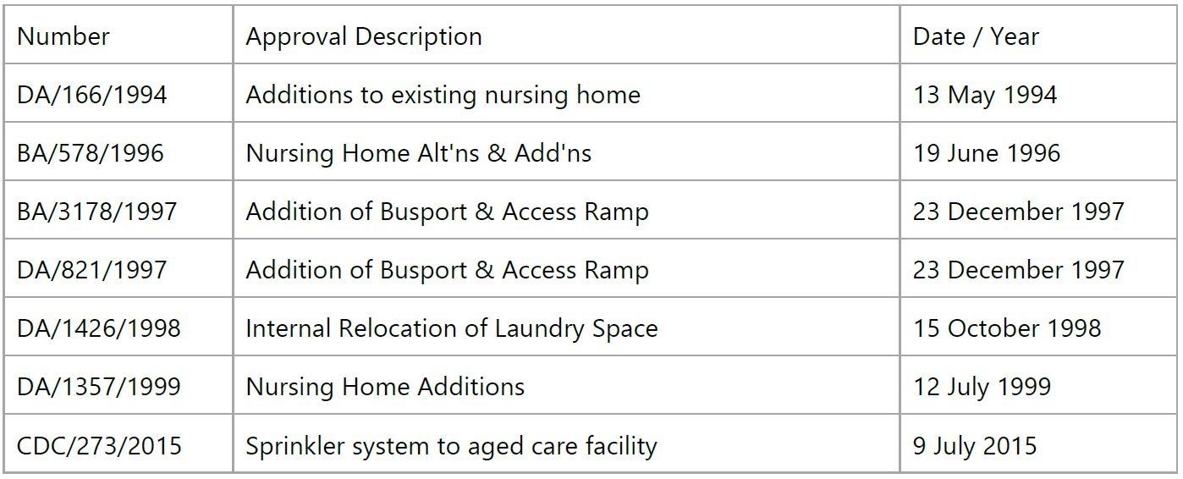
By the early 2000’s the development had taken the form still present, and as depicted in the approved plan extracts included below from DA/166/1994 and DA1357/1999. The existing development has been variously described in Council’s records as a Private Hospital, Nursing Home, Nursing Home and Hospital and a Rest Home with an approved capacity of up to 88 beds.
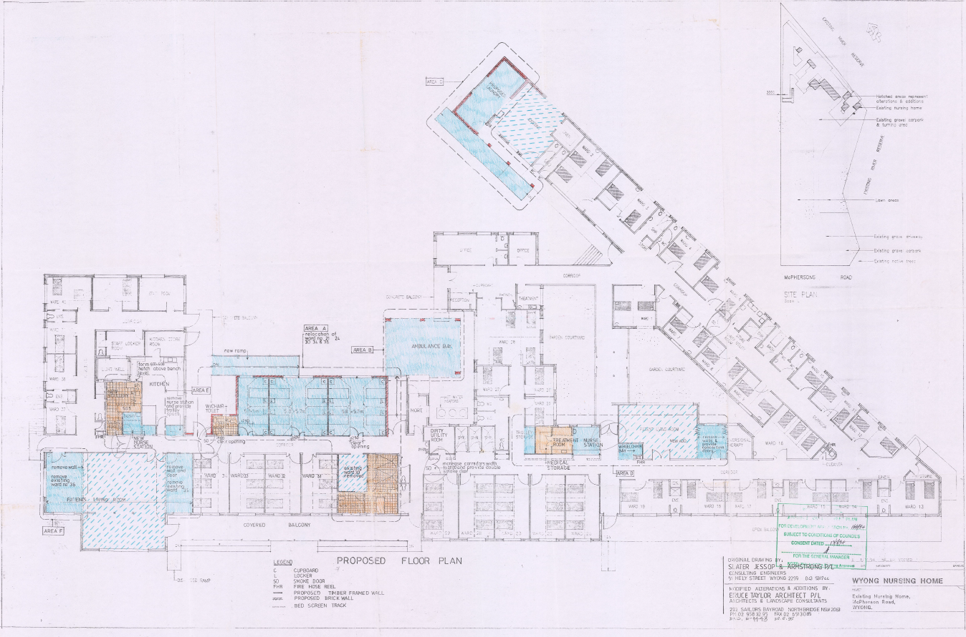
Figure 6: Approved Plan DA/166/1994

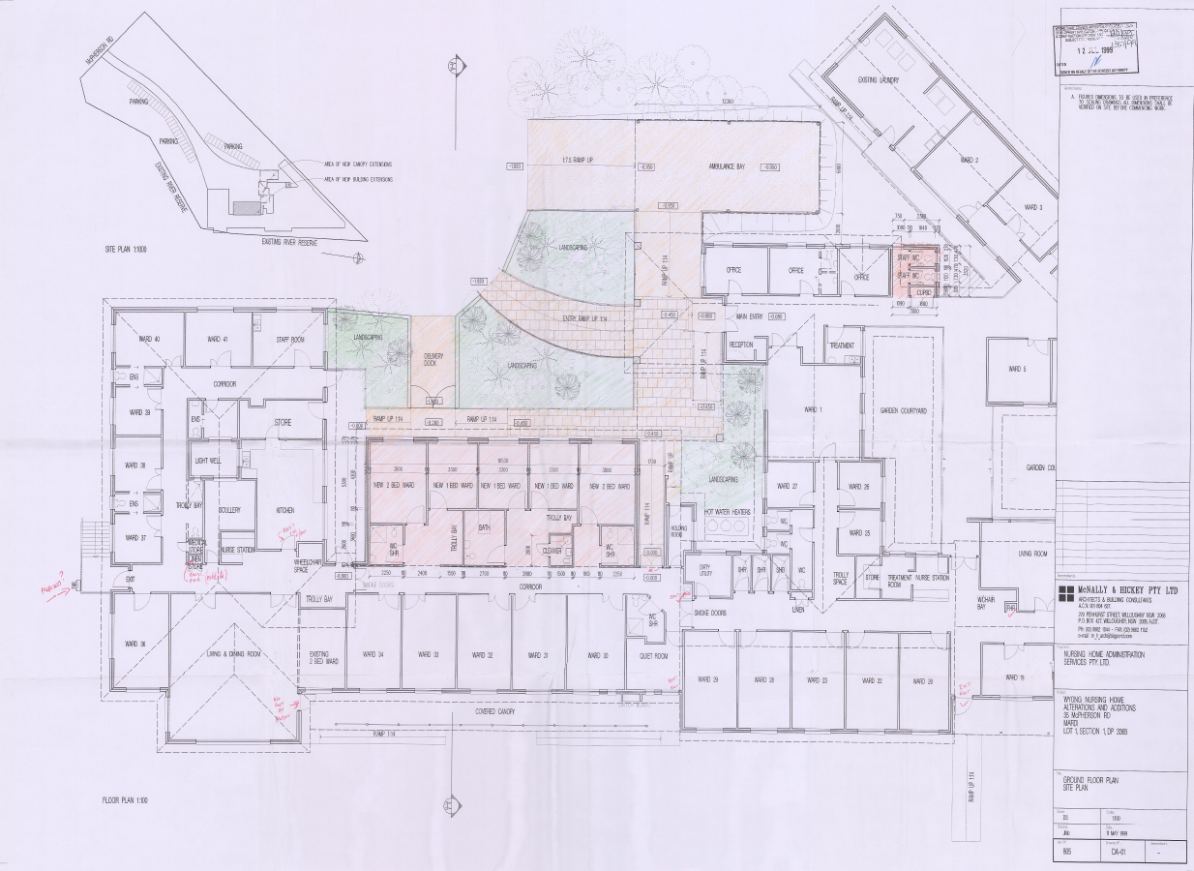
Figure 7: Approved Plan DA1357/1999
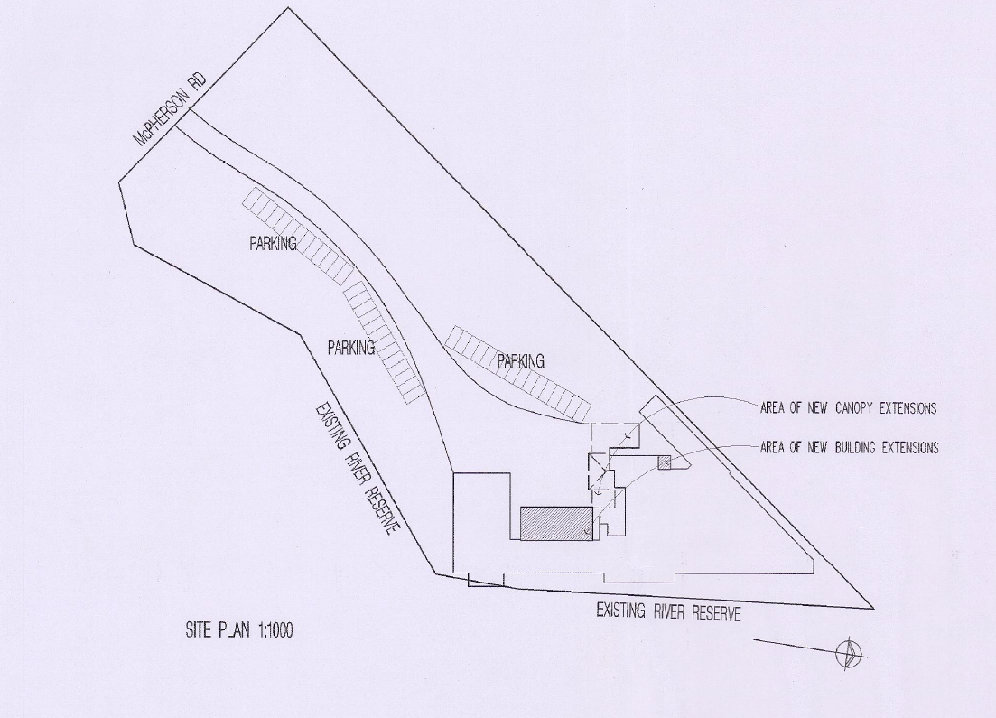
Figure 8: Site Plan as approved DA1357/1999

It is considered that in terms of contemporary land use definitions the existing development would be defined as seniors housing, specifically, a residential care facility, under the WLEP 2013. Regardless, none of the descriptions of development contained in Council’s files are permitted on the site under either WLEP 2013 or CCLEP2022 and the site is considered likely to benefit from existing use rights.

- STATUTORY CONSIDERATIONS

When determining a development application, the consent authority must take into consideration the matters outlined in Section 4.15(1) of the Environmental Planning and Assessment Act 1979 (‘EP&A Act’). These matters as are of relevance to the development application include the following:

- the provisions of any environmental planning instrument, proposed instrument, development control plan, planning agreement and the regulations
- the likely impacts of that development, including environmental impacts on both the natural and built environments, and social and economic impacts in the locality,
- the suitability of the site for the development,
- any submissions made in accordance with this Act or the regulations,
- the public interest.

These matters are further considered below.

It is noted that the proposal is considered to be (which are considered further in this report):

- Integrated Development (s4.46)

  - Section 4.15(1)(a)(i) - Provisions of Environmental Planning Instruments

The following Environmental Planning Instruments are relevant to this application:

- State Environmental Planning Policy (Planning Systems) 2021
- State Environmental Planning Policy (Resilience and Hazards) 2021
- State Environmental Planning Policy (Transport and Infrastructure) 2021
- Wyong Local Environmental Plan 2013
- Central Coast Local Environmental Plan 2022
- Wyong Development Control Plan 2013
- Chapter 1.2 – Notification of Development Proposals
- Chapter 2.11 – Parking and Access
- Chapter 3.1 – Site Waste Management
- Chapter 3.3 – Floodplain Management
- Draft Remediation of Land SEPP;

A summary of the key matters for consideration arising from these State Environmental Planning Policies are outlined in Table 3 and considered in more detail below.

Table 4: Summary of Applicable Environmental Planning Instruments, Plans and Policies (Preconditions in bold)
EPI | Matters for Consideration | Comply (Y/N)
SEPP (Planning Systems) 2021 | Section 2.19 declares the proposal as regionally significant development pursuant to Section 5(b) of Schedule 6 as the development involves the change of use to a community facility with a CIV of more than $5M. | Y
Infrastructure SEPP | - Clause 45 (Determination of development applications—other development) – electricity transmission - the proposal is satisfactory subject to conditions.  - Clause 101 Development with frontage to classified road  - Clause 102(2) Impact of road noise or vibration on non-road development  Clause 104(3) - Traffic-generating development | N/A
Resilience and Hazards SEPP | - Chapter 2 (Coastal Management) – ss2.10 & ss2.11 & Div.5 - The site is located within the Coastal Use Area and the Coastal Environment Area. The development is not likely to have an adverse impact on the matters referred to in either ss2.10 or 2.11. The development is not considered likely to cause increased risk of coastal hazards on the site or other land and the site is not subject to the coastal management program for the purposes of Division 5.  - Chapter 4 (Remediation of Land) – ss4.6(1) & ss4.6(2) Whether the land is contaminated has been considered in the assessment of the proposal. A review of the land use history, aerial photographs and an inspection of the site has not revealed any evidence of potentially contaminating land uses being carried out on the site. The development application has been reviewed by Council’s relevant officer who has advised that there are no outstanding contamination concerns related to the site. | Y
LEP | - Clause 2.3 – Permissibility  - Clause 5.21 – Flood planning considerations  - Clause 7.1 – Acid Sulfate Soils  - Clause 7.9 – Essential Services | Y
DCP | Wyong Development Control Plan 2013  - Chapter 1.2 – Notification of Development Proposals  - Chapter 2.11 – Parking and Access  - Chapter 3.1 – Site Waste Management  - Chapter 3.3 – Floodplain Management | Y
Draft EPIs | Draft SEPP (Remediation) 2018. No compliance issues identified. | Y

State Environmental Planning Policy (Planning Systems) 2021

State Environmental Planning Policy (Planning Systems) 2021 applies to the proposal as it identifies if development is regionally significant development. In this case, pursuant to s. 2.19, the proposal is a regionally significant development as it satisfies the criteria in s. 5 (Private infrastructure and community facilities over $5 million) of Schedule 6 of the SEPP (Planning Systems) 2021. The proposal is development with a CIV of $8,231,000 (excluding GST). Accordingly, the Hunter and Central Coast Regional Planning Panel is the consent authority for the application. The proposal is consistent with this Policy.

State Environmental Planning Policy (Resilience and Hazards) 2021

- Chapter 2 – Coastal Management

The site is located within the Coastal Use Area and the Coastal Environment Area and is therefore subject to the provisions of subsections 2.10 and 2.11 of Chapter 2 – Coastal Management of State Environmental Planning Policy (Resilience and Hazards) 2021 (‘SEPP RH’). The development is not likely to have an adverse impact on the matters referred in in either ss2.10 or 2.11. The development is not considered likely to cause increased risk of coastal hazards on the site or other land and the site is not subject to the coastal management program for the purposes of Division.5. A summary of considerations is included below.

Section 2.10 - Development on land within the coastal environment area

Consent must not be granted unless the consent authority has considered whether the proposed development is likely to cause an adverse impact on the following:

Table 5: Section 2.10 SEPP RH considerations

Matters for Consideration | Compliance
(a) the integrity and resilience of the biophysical, hydrological (surface and groundwater) and ecological environment | The proposal is not likely to cause adverse impacts on the biophysical, hydrological, or ecological environment.
(b) coastal environmental values and natural coastal processes | The proposal will not impact on the geological and geomorphological coastal processes.
(c) the water quality of the marine estate (within the meaning of the Marine Estate Management Act 2014, in particular, the cumulative impacts of the proposed development on any of the sensitive coastal lakes identified in Schedule 1 | The proposal will not result in an adverse impact on the water quality of the marine estate and does not drain to a sensitive lake contained in Schedule 1.
(d) marine vegetation, native vegetation and fauna and their habitats, undeveloped headlands and rock platforms | The proposal will not result in an adverse impact on native vegetation or fauna, undeveloped headlands, and rock platforms.
(e) existing public open space and safe access to and along the foreshore, beach, headland or rock platform for members of the public, including persons with a disability, | Despite the existing encroachment on the adjoining reserve, the development is not likely to adversely impact access to public open space.
(f) Aboriginal cultural heritage, practices and places | There are no identified aboriginal cultural heritage items on the site.
(g) the use of the surf zone. | There will be no impact on the use of the surf zone.

There have been no adverse impacts identified in the consideration of ss2.10(1) that would engage the further considerations under ss2.10(2).

2.11 Development on land within the coastal use area

Consent must not be granted unless the consent authority has considered the following:

Table 6: Section 2.11 SEPP RH Considerations
Matters for Consideration | Compliance
(a) whether the proposed development is likely to cause an adverse impact on the following:  i. existing, safe access to and along the foreshore, beach, headland or rock platform for members of the public, including persons with a disability,  ii. overshadowing, wind funnelling and the loss of views from public places to foreshores,  iii. the visual amenity and scenic qualities of the coast, including coastal headlands,  iv. Aboriginal cultural heritage, practices and places,  v. cultural and built environment heritage, | Despite the existing encroachment onto the adjoining reserve, the development will not adversely impact on access to the coastal use area.  The proposal seeks to utilise an existing building which is considered to have acceptable impact on the visual amenity, scenic qualities, overshadowing, wind funnelling and views within the coastal use area.  There are no known objects, areas, or items of heritage significance on the land, and no potentially adverse impacts on cultural or environmental heritage have been identified.
- (b) is satisfied that  - i. the development is designed, sited and will be managed to avoid an adverse impact referred to in paragraph (a), or  - ii. if that impact cannot be reasonably avoided—the development is designed, sited and will be managed to minimise that impact, or  - iii. if that impact cannot be minimised—the development will be managed to mitigate that impact, | There have been no adverse impacts identified in the consideration of ss2.11(1) that would engage the further considerations under ss2.11(2).
(c)has taken into account the surrounding coastal and built environment, and the bulk, scale and size of the proposed development | The bulk and scale of the proposed development is considered satisfactory for its type and location.

• Chapter 4 – Remediation of Land

The provisions of SEPP RH - Chapter 4 (Remediation of Land) have been considered in the assessment of the development application.

Section 4.6 of SEPP RH requires consent authorities to consider whether the land is contaminated, and if the land is contaminated, it is satisfied that the land is suitable in its contaminated state (or will be suitable, after remediation) for the purpose for which the development is proposed to be carried out.

A review of the land use history, aerial photographs and an inspection of the site has not revealed any evidence of potentially contaminating land uses being carried out on the site. The development application has been reviewed by Council’s relevant officer who has advised that there are no outstanding contamination concerns related to the site, and for the purposes of ss4.6(1) it is reasonable to conclude that there is a low likelihood of contamination.

The development and the land is not otherwise mentioned in ss4.6(4) and accordingly the provisions of ss4.6(2) are not engaged by the proposal and consent may be granted. The proposal is considered consistent with the provisions of Chapter 4 of the SEPP.

State Environmental Planning Policy (Transport and Infrastructure) 2021

- Section 2.122 - Traffic-generating development

The proposed development does not derive access from a classified road and the access is not within 90m of a classified road and therefore does not meet the criteria for a traffic-generating development.

Central Coast Local Environmental Plan 2022 (CCLEP 2022)

The Central Coast Local Environmental Plan 2022 (CCLEP 2022) was published on 24 June 2022 and commenced on 1 August 2022 and has been considered in the assessment of the application. In accordance with the savings provisions under clause 1.8A, this application was lodged prior to the commencement of the new Plan and as such the provisions of the WLEP 2013 continue to apply.

Under CCLEP 2022, the site will retain its same C3 and RE1 zoning and the development, as proposed, will remain permissible with consent in the relevant zones. There are no new or amended Clauses or provisions warranting further discussion.

Wyong Local Environmental Plan (WLEP) 2013

Permissibility
The development application proposes a change of use of the premises from a residential care facility to a community facility.
The site is zoned C3 Environmental Management under the WLEP 2013, and a community facility is permitted with consent in that zone. As noted previously, the existing development does encroach onto the adjoining reserve which is zoned RE1 under WLEP 2013 and a community facility is permitted with consent in that zone also. The application has not sought to rely on the existing use provisions of the Act.

A community facility is defined by the WLEP 2013 as:
community facility means a building or place—
(a) owned or controlled by a public authority or non-profit community organisation, and
(b) used for the physical, social, cultural or intellectual development or welfare of the community,
but does not include an educational establishment, hospital, retail premises, place of public worship or residential accommodation.

The question of the proper characterisation of the proposed development as a community facility was raised during the assessment of the application.
There are several limbs to the community facility definition, firstly being the ownership or control of the facility by either a public authority or a non-profit community organisation.
The proposed development will be both owned and operated by Yerrin Eleanor Duncan Aboriginal Health Service (YEDAHS) which is registered (as Yerrin Aboriginal Health Services) with the Australian Charities and Not-for-profits Commission (ACNC) as a Charitable and Public Benevolent Institution. YEDAHS is a community-controlled organisation for the provision of culturally appropriate health care. It is considered that the development will be owned and controlled by a non-profit community organisation.
The second limb of the definition requires the development to be used for the physical, social, cultural, or intellectual development or welfare of the community. In this instance the proposal is intended to consolidate the existing operations of YEDAHS which currently operate across several sites. There are descriptions of the main functions carried out by YEDAHS within the Statement of Environmental Effects and the Plan of Management submitted with the development application. The main functions are also depicted in the following figure provided in the 2019-2020 Annual Report.
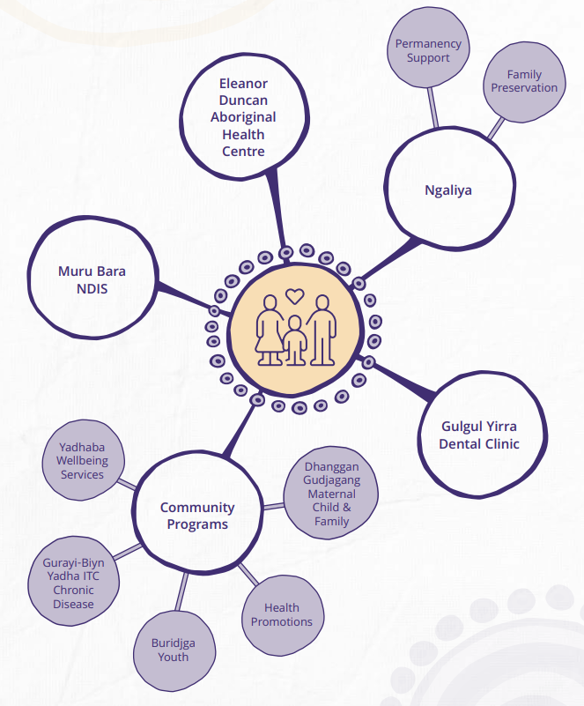
Figure 9: Description of services provided by YEDAHS 2019-2020 Annual Report

It is considered that the proposed development would satisfy part (b) of the community facility definition given the use will provide for the physical, social, cultural, intellectual development and welfare of the aboriginal community.
Lastly, to satisfy the definition of community facility, the development must not include an educational establishment, hospital, retail premises, place of public worship or residential accommodation. The proposed development does not contain any of those uses and may be characterised as a community facility.
The nature of the proposed use being for total person care includes various health elements that may be separately characterised as a medical centre/health services facility. It is noted that the dental facility described as part of the suite of YEDAHS functions will not be carried out on the subject site. There is a question of whether the medical centre is ancillary to the broader use or is it a use in its own right rendering the proposal a mixed use.
Planning Circular PS 13-001 – How to characterise development provides guidance on the appropriate characterisation of development and appears to borrow from renown authorities that deal with the characterisation of development such as Foodbarn Pty Ltd v Solicitor-General (1975) 32 LGRA 157 and Chamwell Pty Limited v Strathfield Council [2007] NSWLEC 114.
PS13-001 provides that development is for a particular purpose if that purpose is the dominant purpose of the development. This purpose is the reason for which the development is to be undertaken or the end to which the development serves. To determine whether a development is (or will be) for a particular purpose, an enquiry into how that purpose will be achieved by the development is necessary. The assessment will vary depending on the facts of each case. An ancillary use is a use that is subordinate or subservient to the dominant purpose. The concept is important when a development involves multiple components on the same land.
Legal advice was sought in relation to the characterisation of the proposed development. This advice has been provided to the Regional Planning Panel and is summarised as follows:
- The dominant purpose of the Proposal is for a “community facility” as defined in the Wyong LEP as outlined in the application and additional information provided on 10/03/2022.
- Whilst a component of the proposal does also satisfy the definition of ‘health services facility’ under the Wyong LEP, this purpose is likely to be ancillary to the dominant purpose (ie. community facility). The proposal incorporates accessibility to a range of integrated community programs to improve the wellbeing of the Aboriginal community. It identifies that the majority of proposed internal floor space and staff is to be allocated to program-based activities, when compared to the number of multi-purpose consulting rooms and treatment rooms for health services. In addition, the combination of these community services into the one building, with one component being dedicated to health services on a multi-purpose basis, further promotes the community facility generally.
- On this basis, the Proposal would be permissible with consent in this context. Although ‘health services facilities’ are prohibited on land zoned C3 in the Wyong LEP, it is identified as being ancillary to the dominant purpose for the site (ie. ‘community facility’), which is permissible with consent in the C3 zone. Being ancillary, the ‘health services facility’ is not an independent use, and is therefore, permissible.

- The Applicant’s additional information expressly provides that:
“The principle purpose of the community facility is to empower the Aboriginal community to improve their wellbeing by accessing culturally responsive and holistic care through a range of integrated community programs. These programs address the physical, social, cultural, emotional and spiritual wellbeing needs and clinical services are provided only to further the purpose of improving wellbeing”.
- The internal floor space and staff allocated for program-based activities and initiatives is much greater than the space allocated for health services. That is, the Applicant’s additional information identifies that 22 rooms will be allocated for program-based activities, with the current number of program staff being 58. In comparison, 12 multi-purpose consulting rooms and 4 treatment rooms to support visiting clinicians, most of whom will work 1-2 days per week, will be allocated for health services;
- The Applicant’s community services are spread over 6 separate tenancies in Wyong at present. This Proposal seeks to amalgamate those services into one building, with one component being dedicated to health services on a multi-purpose basis. This component of the Proposal helps to further promote the community facility generally.
- Although “health services facilities” are prohibited on land zoned as C3 in the Wyong LEP, it is considered ancillary to the dominant purpose for the site (i.e. “community facility”) which is permissible with consent having regard to the C3 land use table in the Wyong LEP; and
- The case of Foodbarn provides that if a prohibited use is ancillary or subservient to a permissible use, and is not an independent use, then the ancillary use will be permissible.
Having regard for the legal advice provided and the guidance in PS13-001 and the authorities cited therein, the consideration of the use in its entirety, from a broad and practical sense, leads to a conclusion that the development is for a community facility which is permissible with consent in the C3 and RE1 zones under the WLEP 2013, and while a medical centre would be prohibited in the subject zones, that component of the use of the building is considered to be ancillary to the permitted use as a community facility.
- Clause 2.3 – Zone Objectives and Land Use Table

The consent authority must have regard to the objectives of the relevant zone when determining a development application. The objectives of the zone are included below.
C3 Environmental Management
• To protect, manage and restore areas with special ecological, scientific, cultural or aesthetic values.
• To provide for a limited range of development that does not have an adverse effect on those values.
The site is located in proximity to the banks of the Wyong River and although is not mapped as containing biodiversity values, is part of the riverine corridor which has aesthetic and ecological values.
The proposed development is comprised of the change of use of an existing building for the purposes of a community facility and in this regard, generally preserves the character of the area, and is unlikely to have an adverse impact on the values of the area. The plan of management contains provisions for appropriate action to be taken with respect to the Grey-headed flying fox.
The proposed development is not considered to be adverse to the objectives of the C3 Environmental Management Zone.
The objectives of the RE1 Public recreation zone are as follows
RE1 – Public Recreation
• To enable land to be used for public open space or recreational purposes.
• To provide a range of recreational settings and activities and compatible land uses.
• To protect and enhance the natural environment for recreational purposes.
• To provide linked open space for ecosystem continuity, public access, local community recreation and waterway protection.
• To provide space for integrated stormwater treatment devices for flow and water quality management.
• To enable ancillary development that complements land zoned for recreational purposes
The development is not for a recreation purpose and does not facilitate the utilisation of the land for the intended outcomes that may be deduced from the objectives of the RE1 zone. In this instance, the objectives of the RE1 zone have been engaged via a small and incidental encroachment which does not appear to have had a detrimental impact on the broader use of the RE1 zoned land during the 50 or so years of the previous use, and the proposed use is not considered to pose any greater risk to the RE1 zone being utilised in accordance with the objectives of the zone. In this regard while the proposal does not further the objectives of the RE1 zone, the status quo is considered reasonable.
- Clause 5.10 - Heritage conservation

Clause 5.10 of WLEP 2013 establishes that consent is required with respect to certain development, however, in this instance the provisions of this clause are not engaged as the building is not a heritage item, the site is not within a heritage conservation area, and there have been no Aboriginal objects or places of heritage significance identified on the site.

Notwithstanding, the construction of the parking area will involve the removal of the grass and ground cover vegetation therefore a condition of consent is recommended to ensure appropriate action is taken should any heritage items be found during works.

- Clause 5.21 – Flood planning

The entire site, including the existing building, are within the flood planning area.
State Environmental Planning Policy Amendment (Flood Planning) 2021 removed clause 7.2 from the WLEP 2013 and the Standard Instrument (Local Environmental Plans) Amendment (Flood Planning) Order 2021 introduced clause 5.21. The subject application was made after the various savings being relevant at 14 July 2021 and is therefore subject to the provisions of clause 5.21.
Subclause 5.21 (2) provides that development consent must not be granted to development on land the consent authority considers to be within the flood planning area unless the consent authority is satisfied that the development:

(a) is compatible with the flood function and behaviour on the land, and
(b) will not adversely affect flood behaviour in a way that results in detrimental increases in the potential flood affectation of other development or properties, and
(c) will not adversely affect the safe occupation and efficient evacuation of people or exceed the capacity of existing evacuation routes for the surrounding area in the event of a flood, and
(d) incorporates appropriate measures to manage risk to life in the event of a flood, and
(e) will not adversely affect the environment or cause avoidable erosion, siltation, destruction of riparian vegetation or a reduction in the stability of riverbanks or watercourses.

Subclause 5.21 (3) provides that in deciding whether to grant development consent on land to which this clause applies, the consent authority must consider the following matters:

(a) the impact of the development on projected changes to flood behaviour as a result of climate change,
(b) the intended design and scale of buildings resulting from the development,
(c) whether the development incorporates measures to minimise the risk to life and ensure the safe evacuation of people in the event of a flood,
(d) the potential to modify, relocate or remove buildings resulting from development if the surrounding area is impacted by flooding or coastal erosion.
The heads of consideration contained with clause 5.21 of WELP 2013 are addressed below and in relation to Chapter 3.3 – Floodplain Management of Wyong Development Control Plan 2013, in the relevant section of this report.
A detailed review of the flooding characteristics, Wyong River Catchment Floodplain Risk Management Study and Draft Plan, implications and recommended response has been provided in the Mardi Flood Risk Management Report (MFRMR) and associated Flood Risk Emergency Response Plan (FERP) prepared by Molino Stewart Environment & Natural Hazards. This information supports the proposed development.
The site is impacted by a range of flood events up to and including the Probable Maximum Flood (PMF). The flood levels for a range of events are included below.
- 20% AEP: 2.21 m AHD
- 5% AEP: 3.82 m AHD
- 1% AEP: 4.57 m AHD
- Probable Maximum Flood (PMF): 7.79 m AHD
The area of the site containing the building is slightly higher than McPherson Road, the access to the site and the proposed parking area.
The following table taken from the MFRMR details the level of affectation experienced by the building.
Table 7: Flood and Building Floor Level – MFRMR Molino Stewart
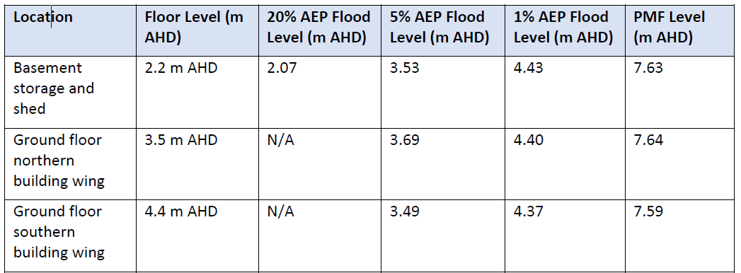
The table shows that in the 5% AEP flood event, the northern wing of the building will experience flooding however, the southern wing is above the 1% AEP level with no real provision of freeboard, which is otherwise typically included in design levels to account for errors in modelling and/or precise local conditions such as wave action. The basement storage area is particularly vulnerable to flooding. All parts of the building are significantly inundated during the PMF.
The proposed development is not anticipated to adversely affect flood behaviour either on the site or the surrounding properties, nor result in any avoidable adverse effects to the environment through erosion, siltation, destruction of riparian vegetation, or a reduction in the stability of riverbanks or watercourses.
Evacuation from the subject site will be required at an early stage in comparison to the surrounding areas, and therefore is not likely to detrimentally impact the existing evacuation capacity of the area. The flood affectation has long been established and due to the vulnerability of the former residents of the site there was implications for emergency services in relation to assisting in the evacuation of the site. The occupants of the site under the proposed development would self-extricate, returning the emergency services capacity previously occupied by the site to the community.
The consultant’s flood expert has recommended measures to address the flood impacts on the building which are reproduced below. It is noted that building works would also be required to comply with the Building Code of Australia.
- No dangerous materials, chemicals, or fuel will be stored in the basement storage area or shed due to their low floor levels.
- No valuable property will be stored in the basement or shed, and any goods stored within them will be elevated off the ground on shelving.
- Within the building, all valuable goods will be stored elevated on shelving or in cabinets above the floor level.
- The main electrical distributor hub for the building as well as distributor box 1 are located at an approximate level of 5.4 m AHD, which is above the 1% AEP floor level plus free board (0.5 m).
- Where possible, internal walls, fixtures, fittings, furniture and flooring will be made of flood compatible materials.
In the 1% AEP, the site is described as having a hydraulic hazard up to the H5 category and H6 during the PMF event, which has significant implications for the safe occupation of the site. The nature of the site results in the building being a low flood island, but due to the hazards experienced, the building cannot be relied upon to provide safe refuge for all flood events, meaning the site must be evacuated to preserve life.
The low-level access, parking, and surrounding road network, result in access to the site being impacted during high frequency events. The MFRMR identifies that the site access becomes hazardous in the 20% AEP event. There is no reliable ability to predict if a flood event will not progress as it is unfolding, with the level of precision required to safely occupy the subject site once the access becomes hazardous. This is further confirmed by the length of isolation experienced by the site during a flood event, for example it is anticipated the site will be isolated for 1-7 hours during the 20% AEP event.
Accordingly, the MFRMR contains detailed consideration of the ability to provide adequate flood warning and evacuation and the practical response is articulated in the FERP.
Early evacuation is recommended in the Applicant’s Flood Risk Management Report. While early evacuation is ideal, it is dependent on diligence to the flood trigger levels and correct application of evacuation orders. The Applicant’s Flood Emergency Plan states that there is a maximum of one hour to evacuate during a 2-hour design Probable Maximum Precipitation. There is a considerable risk that Early Evacuation may not be successful, and occupants become isolated. It is imperative that the FERP is complied with.
Brown in Renaldo Plus 3 Pty Ltd v Hurstville City Council [2005] NSWLEC 315 established the following considerations when determining whether it is appropriate, in a particular circumstance, to rely on a Management Plan, which in this instance is the FERP.

Consideration of the principles in that decision have been considered and are included below.

1. Do the requirements in the Management Plan relate to the proposed use and complement any conditions of approval?

The provisions of the FERP are not contrary to the use sought and have been prepared to be implemented in similar terms to the management of other incidental risks ordinarily faced during the occupation of a building such as a building fire. The implementation of the FERP would not lead to conflict with other conditions of consent.

2. Do the requirements in the Management Plan require people to act in a manner that would be unlikely or unreasonable in the circumstances of the case?

The FERP requires specific actions of the nominated flood warden but also introduces the management of flood risk to the occupants of the site through induction training and like. Due to the prospect of the site being evacuated for events that do not progress beyond a relatively minor event, complacency may be of concern. To address this concern the future operator of the site has provided the following in a written submission dated 30 September 2022.

‘…As noted in the RPP meeting of 17th August 2022, Yerin have considered and acknowledge the very specific risk associated with flooding and that this can be managed by us as the operator.

Yerin also notes and acknowledges that the events experienced recently do not reflect how fast impact can occur (1 in 20 and 1 in 100) flood events for the site, this having been identified and addressed with the Molino Stewart reports.

Yerin notes and acknowledged that the internal site access road inundates more frequently and sits lower than McPhersons Road. This, however, assists to ensure that all personnel and clients will have evacuated the site before local roads are closed/inaccessible for flood evacuation.

As was also noted in the RPP meeting of 17th August 2022, Yerin as the operator of the site acknowledge the potential frequency of flooding and how often they will need to leave the site. This can be easily managed through work-from-home procedures and video conferencing between staff and clients, as demonstrated over the past few years of COVID isolation/restrictions…’

The imbedding of flood risk management into the broader WHS framework and the implementation of the FERP via a dedicated flood warden suggests that the requirements of the FERP will be implemented as required.

3. Can the source of any breaches of the Management Plan be readily identified to allow for any enforcement action?

The FERP contains an Action Checklist which could be maintained by the flood warden for inspection, in addition to the visual inspection of the hardware such as guideposts and gauge warning system, and a review of the actions of flood wardens and occupants during and post flood events which may also be carried out. In this regard it is considered that a review of adherence to the FERP is achievable and practical from a compliance enforcement perspective.

4. Do the requirements in the Management Plan require absolute compliance to achieve an acceptable outcome?

Yes, it is preferable not to have to rely on behavioural elements to ensure the safe occupation of the site however, in this instance, that is not avoidable and cannot be readily addressed via improved design or some other feature of the development.

5. Can the people the subject of the Management Plan be reasonably expected to know of its requirements?

Yes, as mentioned previously, the provisions of the FERP are intended to be implemented across the occupants of the site and this is to be overseen by the flood warden.

6. Is the Management Plan incorporated in the conditions of consent, and to be enforced as a condition of consent?

Yes, a condition of consent has been recommended requiring the implementation and compliance with the FERP at all times.

7. Does the Management Plan contain complaint management procedures?

No and this is not required.

8. Is there a procedure for updating and changing the Management Plan, including the advertising of any changes?

No.

Pearson reinforced the considerations of Brown in Amazonia Hotels Pty Ltd v Council of the City of Sydney [2014] NSWLEC 1247 modifying question 6 to as it appears above.

Based on the considerations above it is reasonable to rely on the FERP to manage risk on the site.
To facilitate efficient evacuation prior to flooding, the access road from McPherson Road to the building is required to be well-delineated. The conditions of consent will require the access to be designed and constructed to withstand the effects of heavy rainfall to assist in evacuation from the site prior to site inundation. The recommended conditions require the internal access road to be delineated through the installation of Heavy-Duty Guideposts on either side of the road to assist wayfinding in adverse conditions.
Given the critical nature of the measures required to be installed to trigger evacuation and facilitate safe evacuation, a deferred commencement condition is recommended requiring appropriate plans, specifications and details be provided for the installation of an on-site flood gauge and warning system.

The MFRMR considers the impacts of climate change on the flood assessment and provides the following commentary.

‘…the site is already low-lying, future sea-level rise associated with climate change will cause more frequent inundation at the site. The Wyong River Catchment FRMSP models climate change impacts of both increased rainfall and increases in the levels of Tuggerah Lake due to sea-level rise. At the highest of the modelled climate change scenarios, 1% AEP flood levels would increase by more than 1 m. This would result in potentially constant inundation of lower lying parts of the site, and much more frequent inundation of the building. Site access may be always cut at these climate change scenario flood levels, and, if not, the site would be isolated much more frequently, with higher hazard floodwaters and for longer durations than currently...’

The development is not likely to adversely contribute to, or alter, flood behaviour because of climate change however, as highlighted in the excerpt from the MFRMR, the development may require further mitigation measures to adapt to changing conditions. It is considered that such adaptation will be part of a broader development pattern and response from the community at large. The development as proposed is satisfactory based on the current flood risk and affectation.

The site is predicted to be significantly affected by hazardous flooding however, the development does not propose any additional floor area and the internal works provide opportunity to harden the existing building against potential flood impacts. On balance the change in use is considered to represent a significant reduction in flood risk compared to the previous residential use/Aged Care Facility.
In this regard the site will be partially occupied throughout the week, during daylight hours, and by persons who are significantly less vulnerable than the previous permanent residents of the site.
Ideally this site would be permanently vacated to completely reduce the risk to life caused by flooding. However as detailed in the Wyong River Flood Risk Management Study and Plan 2020, voluntary purchase by Council for this site is prohibitively expensive.
Despite the severe flood affectation, the proposed development can be supported due to the significant reduction in flood risk and significant reduction in time that there are people on site. The proposed Flood Emergency Plan is expected to further mitigate the flood risk and the development is not likely to have any adverse implications for flood behaviour under the current or future climate change scenarios.
The consent authority may be satisfied as to the relevant matters contained within clause 5.21 of WLEP 2013.

- Clause 7.1 – Acid Sulfate Soils

Clause 7.1 requires consent to be given in certain circumstances to development on land that is mapped as being subject to actual or potential acid sulphate soils (ASS). The subject site has been identified as containing potential Class 3 and 4 ASS and the relevant triggers for consent under cl7.1(2) are included below.

Class 3

- Works more than 1 metre below the natural ground surface.

- Works by which the watertable is likely to be lowered more than 1 metre below the natural ground surface.

Class 4
- Works more than 2 metres below the natural ground surface.

- Works by which the watertable is likely to be lowered more than 2 metres below the natural ground surface

The development application states that the car park design does not require excavation deeper than 1 metre which would be the ordinary trigger for an ASS management plan to be prepared for the proposed works as a precursor to the granting of consent.

A deferred commencement condition is recommended requiring a detailed design of the parking area to be informed by a geotechnical assessment to ensure works are not carried out 1 metre below the natural surface.

- Clause 7.9 – Essential Services

Clause 7.9 requires the consent authority to ensure that services such as water, sewer, electricity, stormwater drainage and road access are available or that arrangements have been made so that services can be adequately provided.

- Water and Sewer

The site has an existing connection to the reticulated water supply and sewer service which are considered adequate for the purposes of the proposed development.

- Access

The proposed access is a gravel access provided off McPherson Road. An off-street parking area is proposed on-site. To ensure safe and practical access to the site a condition of consent is recommended requiring minor civil works within the road reserve in the form of a new industrial/commercial vehicle access crossing with culvert crossing to be constructed in accordance with the standard drawing.

- Stormwater

The stormwater management system is existing and is considered to be adequate. Drainage from the proposed car park is comprised of infiltration however, a detailed design of the car park is recommended to be provided pursuant to a deferred commencement condition.

- Electricity and Telecommunications

The existing services to the land are considered to have sufficient capacity for the proposed development subject to connections being made in accordance with the requirements of the relevant service provider.

Subject to the conditions of consent the proposed development has or will have provision made for the relevant services.

Table 8: Consideration of the LEP Controls
Control | Requirement | Proposal | Comply
Height of buildings  (Cl 4.3(2)) | No specified height limit under Clause 4.3 (and the Height of Buildings Map) under the WLEP. | - | N/A
FSR  (Cl 4.4(2)) | No specified maximum FSR applying to the site under Clause 4.4 (and the Floor Space Ratio Map) of WLEP. | - | N/A
Heritage conservation  (Cl 5.10) | This clause requires consideration of both European and Aboriginal Heritage | The subject site is not in proximity to any European heritage items or heritage conservation areas. An AHIMS search was undertaken, and the site is not in proximity to any recorded Aboriginal sites or declared Aboriginal places. | Yes
Flood Planning (Cl. 5.21) | This clause requires that the Consent Authority be satisfied as to certain matters specified under the clause. | The site is within the flood planning area and adequate reports have been submitted which consider the flood affectation and evacuation of the site. The development is considered satisfactory with regards to Clause 5.21(2) and 5.21(3). | Yes
Acid sulphate soils  (Cl 7.1) | Clause 7.1 requires consent to be given to development on land that is mapped as being subject to actual or potential acid sulphate soils. The subject site has been identified as containing potential Class 3 and 4 ASS. | The development application states that the car park design does not require excavation deeper than 1 metre which would be the ordinary trigger for an ASS assessment. A deferred commencement condition is recommended requiring a detailed design of the parking area to be informed by a geotechnical assessment to ensure works are not carried out 1 metre below the natural surface. | Yes
Essential Services (Cl 7.9) | Clause 7.9 states that development consent must not be granted to a development application unless the consent authority is satisfied that the services that are essential for the development are available or that adequate arrangements have been made to make them available. | The proposal seeks the change of use of an existing building and will utilise the existing services which are considered to be satisfactory. Stormwater drainage of the proposed car park will be further detailed in the satisfaction of the deferred commencement condition. | Yes

The proposal is generally consistent with WLEP 2013.

  - Section 4.15 (1)(a)(ii) - Provisions of any Proposed Instruments

There are several proposed instruments which have been the subject of public consultation under the EP&A Act, and which may be relevant to the proposal, including the following:

- Draft Remediation of Land SEPP

These proposed instruments are considered below:

- Draft Remediation of Land SEPP

The key operational framework of the former SEPP 55 (which has been replaced by SEPP RH) is maintained in the new SEPP which will still require a consent authority to consider whether the site is, or is likely to be contaminated, and permit a consent authority to require additional information to satisfy itself as to whether the land is contaminated. Having regard for the Explanation of Intended Effect, and the site history of use for residential purposes, the proposed development is considered satisfactory with regard to the provisions of the draft SEPP.
  - Section 4.15(1)(a)(iii) - Provisions of any Development Control Plan

The following Development Control Plan is relevant to this application:

Central Coast Development Control Plan 2022 (CCDCP 2022)

The Central Coast Development Control Plan 2022 (CCDCP 2022) commenced on 1 August 2022. In accordance with the savings provisions under clause 1.1.4 of Chapter 1.1, this application has been lodged prior to the commencement of the new Plan and as such the provisions of the WDCP 2013 continue to apply.

Wyong Development Control Plan 2013 (DCP)

The following Chapters of Wyong Development Control Plan 2013 (‘the DCP’) are relevant to this application:

- Chapter 1.2 - Notification of Development Proposals
- Chapter 2.11 - Parking and Access
- Chapter 3.1 - Site Waste Management
- Chapter 3.3 – Floodplain Management

DCP Chapter 1.2 – Notification of Development Proposals

The development was publicly notified in accordance with Chapter 1.2 with one submission being received from the NSW Department of Planning, Industry and Environment – Crown Lands who is an adjoining owner, raising no objections to the development.

DCP Chapter 2.11 - Parking and Access

The proposed development is comprised of approximately 1317.5m2 of GFA which, based on the requirements of clause 3.2 summarised in the table below, requires the provision of 66 on site car parking spaces.

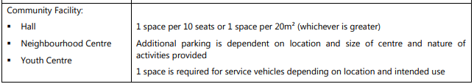Figure 10: Table extract from Cl 3.2 of WDCP 2013 Chp 2.11

The applicant has offered an alternate calculation based on the uses that collectively form the proposed community facility which is summarised in the table below which has been extracted from the Statement of Environmental Effects.
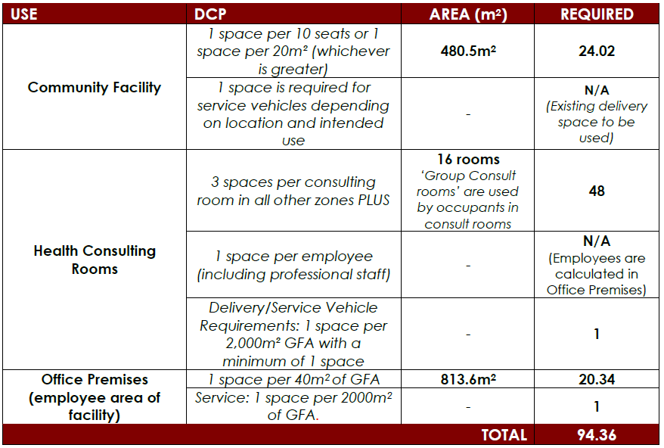
Figure 11: Applicant’s car parking table from SEE

The proposal has been designed to provide 95 parking spaces in accordance with the applicant’s calculation in the table above.
The applicant provided further advice in relation to the car parking provision via email dated 30/5/2022:

On average 89 car parking spaces would be used on-site at any time between 9am to 5pm for the Community Facility. This is based on the following:

- In-reach staff and administration staff numbers daily average (permanent on site Monday to Friday) = 62 per day

- Out-reach staff numbers daily (outreach staff Monday to Friday in two shifts) – 24/2 = 12 per day

- Average visiting Staff daily = 2 per day

- Average daily in-reach clients (by appointment only) – 104 per day / 8 hours = 13 per hour

Note: Outreach clients do not attend the site.

On average, there will be 76 car spaces used by in-reach staff, outreach staff, and visiting staff per day. On average, there will be 13 car spaces used by in-reach clients per hour. Thus, on average 89 car parking spaces would be used at any time between 9am to 5pm. This is a conservative approach and not taking into consideration for the in-reach clients who are picked up by Yerin owns bus transport. This can vary every day and is also by appointment only.

Based on the Statement of Environmental Effects and the applicant’s further submission, the proposed parking is more than adequate and potentially an over-supply. Given the relatively isolated nature of the site, and the unformed frontage and street verges in the area, it is considered that there is little opportunity for overflow parking to be accommodated within the road reserve and a conservative approach to the provision of parking is supported.
DCP Chapter 3.1 Site Waste Management

In accordance with DCP Chapter 3.1 the application includes a Waste Management Plan for the development outlining the waste disposal, re-use and recycling (on and off site) for the demolition, construction and operational stages of the development. A condition has been included requiring the development to be carried out in accordance with the submitted management plan.

DCP Chapter 3.3- Floodplain Management
The site is identified as being within Precinct 4 - High Hazard, with the area occupied by the existing building being Precinct 3 – Flood Storage and Flow Paths.

The development is classified as a Commercial and Industrial use under Chapter 3.3 and cl.3.1 – Prescriptive Criteria requires a performance-based assessment that addresses cl.3.2 – Performance Based Assessment and Appendix C – Detailed Assessment Criteria. This assessment is to demonstrate that the proposed development is compatible with the flooding characteristics of the site.

A Flood Risk Management Report and associated Flood Emergency Response Plan have been prepared by a suitably qualified consultant to consider the flood affectation, and address the relevant provisions of the WLEP 2013 and Chapter 3.3 of the WDCP 2013. The following table is taken from the Flood Risk Management Report and summaries the performance-based assessment in accordance with cl. 3.2.

Table 9: Summary of Considerations of Chapter 3.3 of WDCP 2013 – Molino Stewart

Clauses | Comments Pertaining to the Site
a) is compatible with the established flood hazard of the land. In areas where flood hazard has not been  established through previous studies or reports, the flood hazard must be established in accordance with the  Floodplain Development Manual. | The site will have to show that its use as a non-residential  community centre is compatible with the high flood hazard of  the land.  This can be supported by it not being a residence,  and only being used during normal business hours (i.e.  occupied less than 25% of the time).  The Flood Emergency Response Plan sets out the procedures in place that provide for early evacuation before there is flooding to the parking lot and access to the site is cut in any event and demonstrates how risk to life will be managed.
b) will not significantly adversely affect flood behaviour resulting in  detrimental increases in the  potential flood affectation of other development or properties; | The proposed development is on a site currently containing a  vacant aged care facility which had operated on the site for  more than 20 years.  Therefore, as long as the building footprint and site levels are not modified, the proposed development will not have an impact on flood behaviour.
c) incorporates appropriate  measures to manage risk to life and property from flood; | The site will require robust flood management procedures in  place that ensure early evacuation of the site in case of flooding. This is fully detailed in the Flood Emergency Response Plan.
d) will not significantly adversely affect the environment or cause  avoidable erosion, siltation,  destruction of riparian vegetation or a reduction in the stability of river banks or watercourses; | The proposed development is on a site currently containing a  vacant aged care facility which had operated on the site for  over 20 years.  Therefore, as long as the building footprint and site levels are not modified, the proposed development will not adversely impact the environment or cause any of the stated impacts.
e) is not likely to result in  unsustainable social and economic costs to the community as a consequence of flooding. | Appendix C states that this must take into account:  the additional economic and social costs that may arise from  damage to property from flooding should not be greater than  that which can reasonably be managed by the property owner  and general community;  ii land values and social equity – effect both negative and  positive – e.g. development increasing land values, restrictions  decreasing land values, etc;  iii future development (specifically, the ability of the community and individuals to recover from flood events);  iv economic factors both in regard to doing and not doing the  development;  v social issues;  vi servicing the development safely in flood e.g. potable water,  sewer, etc.  The proposed development aims to provide a culturally  enriching and engaging space for Yerin Aboriginal Health  Services to provide an integrated community service to the  local Aboriginal community, promoting ownership of assets  and self-empowerment of local Aboriginal services. It therefore will provide a real and substantial social benefit to  the community.  It can be argued that the social benefit outweighs the cost  that may arise from flood damage. The Flood Emergency  Response Plan details the development’s plans in place for  recovery in case of flood, and the robust flood management  procedures in place that ensure early evacuation of the site in  case of flooding. It describes how life will be protected in the  event of a flood, and measures to reduce risk to property such  as ensuring valuable assets within the building will be kept  above of the reach of frequent flooding.
f) is consistent with the principles of Ecologically Sustainable Development. | The proposed development is on a site currently containing a  vacant aged care facility which had operated on the site for  over 20 years.  Therefore, as long as the building footprint and  site levels are not modified, the proposed development will  not adversely impact the environment. The adaptive reuse of  an existing building is consistent with the principles of  ecologically sustainable development.
g) adequately considers the impact of climate change.  i It is to be noted that with regard to climate change, appropriate benchmarks based on the best available current information have been used in producing the flood risk management studies and plans that inform this document.  ii Some prescriptive requirements such as flood planning level requirements may be relaxed if  Council can be satisfied that the projected life of the proposed development is for a relatively short term  and therefore does not warrant the imposition of controls that consider impacts beyond the cessation of the proposed  development. This will only be considered for uses where the residual risk to the occupation of the development is considered to be low.  This may include certain temporary or demountable structures but would not include residential developments. | The site is already low-lying and future sea-level rise  associated with climate change will cause more frequent  inundation at the site. The Wyong River Catchment FRMSP  models climate change impacts of both increased rainfall and  increases in the levels of Tuggerah Lake.  At the highest of the modelled climate change scenarios, 1% AEP flood levels would increase by more than 1 m. This would result in constant inundation of lower lying parts of the site. Site access may be always cut at these climate change scenario flood levels, and, if not, the site would be isolated much more frequently, with higher hazard floodwaters and for longer durations than currently.  However, it can be argued that since the proposed  development is not a residential development, and is the  adaptive re-use of an existing building, the long-term future  risk is acceptable. The proposed development can operate in  the meantime with flood evacuation procedures in place and  provide beneficial services to the community until a time at  which the continued use of the site as per the current plans is  no longer sustainable.  There is a considerable uncertainty around the timing and  magnitude of future flood levels associated with climate  change, and it is likely that the proposed development can operate for several decades until there comes a time at which  it must explore solutions to adapt to climate change, such as  raising the development’s parking lot and driveway, in order  to extend the lifetime of the development.  In the future, low points in the parking lot and driveway of the  development could be raised to 1.7 m AHD, which is the level  of the McPhersons Road in front of the development. However, it is noted that care would need to be taken in designing these level changes to ensure they did not block an existing flow path.

The Flood Risk Management Report and associated Flood Emergency Response Plan are considered to have appropriately considered the matters specified by Chapter 3.3 of WDCP 2013. The merits of the proposal have been reviewed by Council’s Development Flooding Engineer who supports the development subject to recommended conditions of consent.

- S7.12 Development Contributions Plan

The development is subject to the Central Coast Council Regional Section 7.12 Development Contributions Plan 2019. Ordinarily development exceeding $200,000.00 would be subject to a levy equivalent to 1% of the value of the development. In this instance however, Council’s Contributions Officer has identified that pursuant to cl 1.5 – Are there any exemptions to the levy? the development meets the following criteria which means a levy will not be imposed.

- Alterations or refurbishment of an existing development, where there is no enlargement, expansion, increase in gross floor area or intensification of the current land use;

The proposed development does not involve the enlargement, expansion or increase in GFA. The proposal is not an intensification of the current use but is a new use that is not considered to be more intensive the historic use and contributions are not required to be levied in this instance.

  - Section 4.15(1)(a)(iiia) – Planning agreements under Section 7.4 of the EP&A Act

There have been no planning agreements entered into and there are no draft planning agreements being proposed for the site.

  - Section 4.15(1)(a)(iv) - Provisions of Regulations

The Environmental Planning and Assessment Regulation 2021 (2021 EP&A Regulation) commenced on 1 March 2022 and replaced the 2000 Regulation. The Environmental Planning and Assessment Regulation 2000 continues to apply to the application in accordance with the savings provisions outlined in Schedule 6 Part 1 of the Environmental Planning and Assessment Regulations 2021 as the application was submitted but not finally determined before 1 March 2022.

Clause 92(1) of the 2000 Regulation contains matters that must be taken into consideration by a consent authority in determining a development application. Demolition work is identified under the clause and is proposed under the application. The demolition works are to be carried out in accordance with the provisions of AS 2601 as addressed in the recommended draft conditions.

Amended plans were received and accepted by Council in accordance with Section 55 of the Regulation 2000. There are no other specific clauses that warrant further discussion in relation to the Environmental Planning and Assessment Regulation 2000.

  - Section 4.15(1)(b) - Likely Impacts of Development

The likely impacts of the development, including environmental impacts, on both the natural and built environments, and social and economic impacts in the locality, must be considered. In this regard, potential impacts related to the proposal have been considered in response to the relevant provisions of the SEPPs, LEP and DCP controls outlined above and in the Key Issues section below.

Context and setting

The site is located within a flood prone corridor adjacent to the Wyong River, and nearby development is reflective of the flooding constraint being comprised of small rural holdings containing dwellings and associated outbuildings, in addition to public lands forming the banks of the river. South of the development beyond the floodway is a mixed-use precinct containing various commercial, retail, and industrial development.

The proposal seeks to utilise the existing structure and construct car parking within the south-western portion of the site. The proposed works will be evident in the immediate vicinity of the site however, the development in general represents a status quo in the context and setting. The use will generate additional traffic in comparison to the historic use of the site due to there no longer being permanent residents on the site however, the setting is not considered to be sensitive this impact. The proposed development is considered compatible within its context and setting.

Privacy, Overshadowing, Bulk, Scale and Character

The physical impacts of the development will remain largely unaltered from the historic use of the site. In this regard there are no building or site works that will result in any undue physical impacts, and it is considered that the development on the site will continue to have a harmonious relationship with the setting and surrounding development.

Access and traffic

The proposed access is a gravel access provided off McPherson Road. An off-street parking area is proposed on-site. To ensure safe and practical access to the site a condition of consent is recommended requiring minor civil works within the road reserve in the form of a new industrial/commercial vehicle access crossing with culvert crossing to be constructed in accordance with the standard drawing.

A Traffic Impact Statement has been provided which details the existing road conditions, traffic volumes and anticipated impacts associated with the proposed development. The description of the existing road conditions within the report are included below.

McPherson Road

McPherson Road is a local road under the care and control of Central Coast Council. It provides an east/west connection with Old Maitland Road to the west and the Pacific Highway to the east. It has a two-lane rural road formation with one travel lane in each direction and signposted speed limit of 50 km/h.

Pacific Highway

Regionally, Pacific Highway to the east is expected to be the main route to the site via McPherson Road and South Tacoma Road. Pacific Highway is a State Road under the care of TfNSW. It provides the main north-south connection for the site. At the South Tacoma Road/Pacific Highway intersection, Pacific Highway has one travel lane northbound and two travel lanes southbound (one lane for overtaking right turning vehicles and eventually merging back to one lane further south).

The Traffic Impact Statement notes that Transport for NSW has studied the existing Pacific Highway and subsequently prepared concept plans for upgrades to the Pacific Highway in the vicinity of the site, including a duplication of the bridge over the Wyong River and an intersection treatment such as a roundabout, to improve access to McPherson Road and South Tacoma Road.

There isn’t a trip generation rate for a community facility use in the RTA (now TfNSW) ‘Guide to Traffic Generating Developments, Updated Traffic Surveys Version 2.2 2002’ and ‘Guide to Traffic Generating Developments – Updated Traffic Surveys (TDT 2013/04a)’. An assumed peak hour generation has been derived based on the capacity of the quantum of parking provided on site and the nature of the use with an expected maximum peak (evening) generation of 67 trips.

The Traffic Impact Statement includes the following analysis of the distribution and travel routes for the peak generation.

PM Peak – 32 (48%) northbound, 35 (52%) southbound.

It is anticipated that the northbound vehicles will use the intersection of South Tacoma Rd / Pacific Highway and turn left to travel towards their destination.

Whereas southbound vehicles will travel on Gavenlock Road, Johnson Street then turn right at the TCS control intersection of Pacific Highway / Johnson Street for safety and to avoid potential delays turning right at the intersection of South Tacoma Rd / Pacific Highway…

Right turning lane on Johnson Street at the intersection of Pacific Highway / Johnson Street is approximately 90m long. Google maps image of the intersection as shown in figure 4.2 below, seems to indicate queue of approx. 35m in the right turning lane during weekday PM peak (4:00-5:00 pm), which demonstrates that the intersection has adequate capacity to accommodate additional traffic generated by the proposed development.

The peak generation equates to less than one car per minute travelling either northbound or southbound on the Highway in the PM peak. Council’s Traffic and Transport Engineer has assessed the proposal and based on the modelling results above it is anticipated that the proposed development will not have a significant impact on the surrounding road network.

Stormwater and drainage

The application includes the construction of an on-site carparking area to accommodate off-street parking for the development. The applicant is proposing a permeable pavement drainage system that relies on infiltration of stormwater into the underlying ground.

The application proposes the use of a proprietery permeable pavment drainage system for the car parking area (Ecoraster). A geotechnical investigations report, identifying infiltration testing that supports the use of this drainage system is recommended under the specifications for the Ecoraster.

Given the proximity of the development to the banks of the Wyong River Council and the underlain Class 3 and Class 4 ASS, it is considered that the consent should be deferred pending the submission of a detailed car park design that is informed by an appropriate geotechnical report.

Aboriginal Cultural Heritage

An Aboriginal Heritage Information Management System (AHIMS) search was carried out which identified that the site is not in proximity to any recorded Aboriginal sites or declared Aboriginal places. A recommended condition of consent will require that if any relics are found during works, that work ceases and the Office of Environment and Heritage and the Local Aboriginal Land Council (LALC) are contacted, and appropriate approvals sought.

Soils impacts, Acid Sulphate Soils (ASS) and groundwater

The subject site has been identified as containing potential Class 3 and 4 ASS as depicted in the figure below.

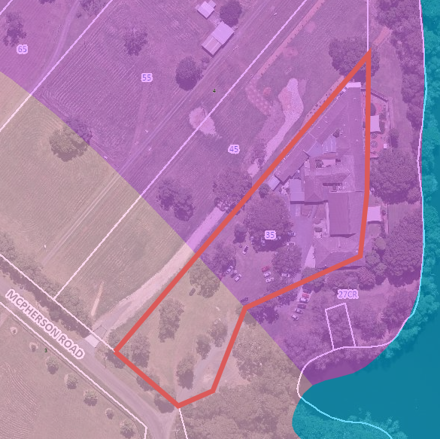
Figure 12: ASS Map showing Class 3 (purple) and Class 4 (brown) ASS location

The development application is not supported by a geotechnical assessment, or a preliminary assessment carried out in accordance with the Acid Sulfate Soils Manual.
The development application states that the car park design does not require excavation deeper than 1 metre which would be the ordinary trigger for an ASS management plan to be prepared for the proposed works as a precursor to the granting of consent.

A deferred commencement condition is recommended requiring a detailed design of the parking area to be informed by a geotechnical assessment to ensure works are not carried out 1 metre below the natural surface.

Earthworks

There are minor earthworks required for the construction of the parking and access with no retaining or deep excavation proposed.

Contamination

The applicant has addressed the requirements under Chapter 3 (Remediation of Land) of State Environmental Planning Policy (Resilience and Hazards) 2021 in respect of potential contamination and remediation impacts by reviewing the site history. As the current and existing land use is not listed as a potential contaminating activity a “Preliminary Contamination Assessment” is not required.

However, due to the age of the current structures that will be required to be demolished there is a potential for asbestos building materials to be present. Therefore, to ensure no legacy issues are created and the health and well-being of the surrounding community and workers are protected, it is recommended that an unexpected finds protocol be conditioned into an overarching Construction Environmental Management Plan for any development consent issued.

Utilities

- Water and sewer servicing

The site has connections to the existing reticulated water a sewer systems that are adequate for the scale and nature of the proposed use. The location of the existing mains is depicted on the figure below with the water main being blue and sewer main red. The proposed works are not likely to adversely impact the existing services and particular protection measures are not warranted.

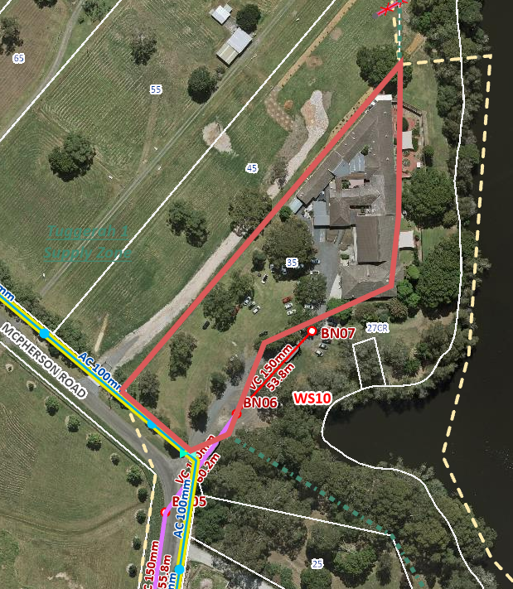
Figure 13: Reticulated Service Mains

The development will require a Section 307 Certificate under the Water Management Act 2000. Water and sewer contributions are required for this proposal, which will be detailed on the WMA Section 306 Requirements letter, to be issued by the Water Assessments team.

- Other utilities

The development will continue to utilise the existing electricity and telecommunication services connect to the site

Flooding impacts

The site is identified as being subject to high hazard flooding with the bulk of the site being a floodway and the area generally occupied by the building being a low flood island. This is depicted on the figure below which depicts the mapped floodway.

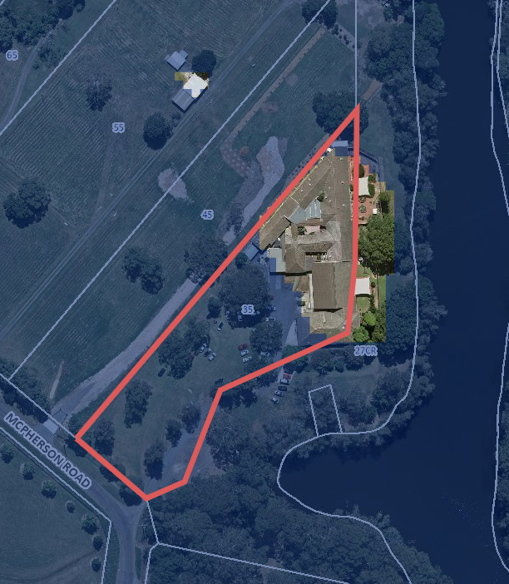
Figure 14: Floodway

Due to the entire site becoming hazardous in an event above the 1% AEP, and the partial inundation and relatively lengthy time of isolation for a range of events up to the 1% AEP, evacuation of the site is the primary flood mitigation strategy to ensure the safety of the occupants of the site. Access to the site becomes inundated in relatively high frequency events and accordingly a management plan has been developed to address the management of the site such that orderly evacuation occurs when the need arises.

It is not possible to eliminate the flood risk via this or any other development of the site and in the circumstances and based on the considerations of the matter in WLEP 2013 and WDCP 2013 the proposed development is considered to be an acceptable use of the site and less at-risk development than the historic use of the site for residential purposes.

Bushfire Impacts

The subject site is not bushfire prone.

Social impact

The development comprises a community facility for the provision of culturally sensitive health and wellbeing services to the community by a community organisation. The development seeks to consolidate the operations of the existing community group to one premises to improve access to the services for the community and to improve business operations. In this regard the development is expected to have a positive social impact and there have been no adverse social impacts identified.

Operational Management

The applicant prepared a Plan of Management has outlined the following aspects of the operation of the site:

- Use of external areas
- Transport Arrangements
- Staff
- Safety and Security
- Parking
- Garden and Lawn Maintenance
- Flooding and Emergency Control Plan
- Waste Management Plan
- Environmental Management
- Review of this Document

The submitted Plan of Management is considered satisfactory.

Economic impact

The proposed development seeks to reduce the expenses incurred by the community organisation operating the facility by consolidating various existing rented spaces into the one site. The development provides employment opportunities and makes services available specifically in some cases to address social and financial disadvantage. The site is heavily flood constrained and is susceptible to impact from flooding that depending on the level of the flood event carry with it an economic cost in terms of clean up and potential reconstruction however, on balance the development will have a positive economic impact and due to the detailed flood planning and assessment carried out as part of the current application be better placed to mitigate against flood impacts than the historic use of the site.

Safety, Security and Crime Prevention

The four principles of Crime Prevention Through Environmental Design (CPTED) have been considered in the design of the proposed new development. The applicant prepared and identified a number of design considerations to discourage anti-social behaviour and minimise the opportunities for criminal activities as included below.

Territorial Enforcement

The frontage of the site is bounded by existing fencing and landscaping where the ‘line of sight’ from the road into the development is maintained.

Surveillance

The community facility provides good surveillance from the road, new car park area, to, and within the facility. CCTV/Security cameras are capable of being installed along the front, rear and eastern boundaries, and to cover the carpark area and within the community facility building. Further, the mere fact that the use will occupy an existing vacant building will greatly improve natural surveillance over the site.

Access Control

The sites entry point and building entry point (pedestrian and vehicle) are capable of being clearly signposted. The site has existing boundary fencing and access to the car park can be restricted outside of opening hours to the general public.
Space / Activity Management
The community facility, with its Plan of Management, will ensure the site is well maintained, and secured. Taking the above into consideration, the proposed development will have a positive impact upon the site and surrounds in terms of CPTED principles.
Noise and Vibration
The proposed use is not noise generating and is not susceptible to the main noise source in the locality being the Pacific Highway.

Air Quality
Council’s Senior Environmental Protection Officer has considered the environmental impacts related to air quality and it is anticipated that this proposal will not significantly impact the surrounding environment. During the construction phase it is anticipated that there may be short term impacts however these can be controlled with a conditional requirement for any development consent issued.
Waste Management
The site plan was amended to include the location of the waste storage are and a waste management plan has been submitted. The development will generally utilise the existing bin store and collection area. The Plan of Management includes the following waste management particulars. rovisions

- Implementing environmental awareness and education with residents, staff and stakeholders.
- Using environmentally safe and sustainable energy sources to meet our needs and invest in improved energy efficiency of products we use.
- Minimising waste and, whenever possible, recycling materials. We will dispose of all waste through safe and responsible methods.
- All waste is to be stored in sealed bags in a clearly marked rubbish storage area.
- Waste is to be collected and conveyed to the central waste container, in preparation for collection by the private waste contractor.
- Waste will be collected by the private waste contractor on a weekly basis (utilising a large bin) and may be extended to 2 times a week if waste increases.

The recommended conditions of consent address ongoing compliance with the waste management plan and the provision of orderly waste management on the site.

Natural Environment

The site comprises of 0.9 ha and consists mostly of cleared or landscaped areas which includes some large remnant native trees. Vegetation along Wyong River includes Casuarina glauca, formative of Swamp Oak Floodplain EEC and large planted Camphour Laurels and Norfolk Island Pines.

The crown land reserve that adjoins the site along Wyong River (Lot 9 DP1206398) and some trees on part of the subject site were observed by Council’s Ecologist to support a Grey-head flying fox camp between February and early June 2021. The population was estimated between 2500-5000 individuals. The Grey-head flying fox is listed as Vulnerable under NSW and Federal legislation.

It is unknown if prior to 2021 the site was used as a camp. A flying fox camp has not been previously recorded in this location or identified in Council’s Flying-fox Management Strategy (FFMS), dated April 2019.

It is possible the site could be used as a camp again and result in possible conflict with humans. According to Council’s FFMS if new camps are created, they would be managed as per the direction given in the strategy.
The Plan of Management includes provisions below for appropriate action to be taken should Grey-head flying foxes camp in proximity to the site.

- Yerin Management will alert Central Coast Council and Crown Lands/DPIE in the event a camp is established again.
- In the event a camp is established, Yerin Management will familiarise themselves with Council’s FFMS including an understanding of appropriate management activities.
- Minimise impacts to the Yerin Eleanor Duncan Aboriginal Community Facility staff, clients and other visitors while conserving flying-foxes and their habitat in accordance with Central Coast Council’s Flying-fox Management Strategy (FFMS).
- Comply with Central Coast Council’s Flying-fox Management Strategy (FFMS).

The proposal does not include the removal of any trees as part of the works. Notwithstanding, the development application does not include a detailed engineering design for the proposed car park and accordingly a full assessment of the potential impacts on the existing vegetation could not be carried out. Deferred commencement is recommended subject to the submission of detailed plans and investigations for the construction of the car park and it is considered that the engineering design should be informed by an arborist report so that impacts to the existing trees is avoided.

Subject to the conditions of consent the development will have satisfactory impacts on the natural environment.

Accordingly, it is considered that the proposal will not result in any significant adverse impacts in the locality as outlined above.

  - Section 4.15(1)(c) - Suitability of the site

There have been no matters identified in the assessment of the subject development application that suggest the proposal will not fit within the locality and preserve the existing and desired character of the area.

The site is adequately serviced and subject to the conditions of consent will have sufficient access and parking. The site is not identified as being bushfire prone however, is subject to flooding.

The flood affectation of the site and the proposed flood mitigation response has been discussed at length in this report and the site has on balance been found to be suitable for the proposed development.

  - Section 4.15(1)(d) - Public Submissions

These submissions are considered in Section 4.3 of this report.

  - Section 4.15(1)(e) - Public interest

The proposal involves the adaptive reuse of an existing building for a purpose that is less prone to affectation than the historic residential use of the land and in doing so brings together services previously catered for in six separate tenancies. The owner and operator of the site is a non-profit community organisation that provides a range of social, health and financial services to the ATSI community and the current proposal seeks to improve access to the services offered and improve the financial viability of the community organisation.

The subject site is subject to flooding which may be adequately managed so there is not an undue impact on the occupants of the site or the community more broadly. There have been no adverse impacts identified that would otherwise negatively affect the community or natural or built environments and the development is considered to be in keeping with the public interest.

- REFERRALS AND SUBMISSIONS

  - Agency Referrals and Concurrence

The development application has been referred to various agencies for comment/concurrence/referral as required by the EP&A Act and outlined below in Table 5.
There are no outstanding issues arising from these concurrence and referral requirements subject to the imposition of the recommended conditions of consent being imposed.

Table 10: Concurrence and Referrals to agencies
Agency | Concurrence/  referral trigger | Comments  (Issue, resolution, conditions) | Resolved
Concurrence Requirements (s4.13 of EP&A Act) (if none – N/A – to show consideration)
Environment, Energy & Science Group within DPIE | S7.12(2) - Biodiversity Conservation Act 2016 |  | N/A
Referral/Consultation Agencies (if none – N/A – to show consideration)
RFS | S4.14 – EP&A Act  Development on bushfire prone land |  | N/A
Integrated Development (S 4.46 of the EP&A Act) (if none – N/A – to show consideration)
RFS | S100B - Rural Fires Act 1997  bush fire safety of subdivision of land that could lawfully be used for residential or rural residential purposes or development of land for special fire protection purposes |  | N/A
Transport for NSW | S138 - Roads Act 1993 for works in the road reserve. |  | N/A
Heritage NSW | S58 of the Heritage Act 1977 for demolition or works etc to an item listed on State Heritage Register or with an interim heritage order. |  | N/A
DPE | S91 Water Management Act 2000. | GTAs Issued 9 January 2023 | Yes

  - Council Referrals

The development application has been referred to various Council officers for technical review as outlined Table 11.

Table 11: Consideration of Council Referrals
Officer | Comments | Resolved
Engineering | Council’s Engineering Officer has requested detail pertaining to the vehicle access and manoeuvring within the site and details and specifications relating to the proposed car park construction. | Yes
Traffic | Council’s Traffic Engineering Officer reviewed the proposal and the subsequent traffic impact assessment report submitted by the applicant and raises no objections to the proposal. | YEs
Building | The Building Officer’s declined to comment. | No
Flooding | Council’s Flood Engineering Officer reviewed the proposal and while it is acknowledged that the site is subject to a high level of flood risk the proposal may proceed subject to recommended conditions. | Yes
Waste | Further information regarding waste management has been provided. | Yes
Environmental Health | Council’s Environmental Health Officer reviewed the proposal and raises no objections to the proposal subject to recommended conditions of consent. | Yes
Tree Assessment | Tree protection measures are required to address the preservation of existing Eucalyptus and Melaleuca trees are to be provided in relation to the final car park design and specification. | No

  - Community Consultation

The proposal was notified in accordance with the Chapter 1.2 of WCP 2013 from 21 October 2021 until 5 November 2021The notification included the following:

- Notification on a website;
- Notification letters sent to the four adjoining and adjacent properties;
- Notification on the Council’s website.

one submission being received from the NSW Department of Planning, Industry and Environment – Crown Lands who is an adjoining owner raising no objections to the development.

- KEY ISSUES

The following key issues are relevant to the assessment of this application having considered the relevant planning controls and the proposal in detail:

  - Characterisation and Permissibility of the Use

The preliminary assessment raised a question regarding the characterisation of the proposed use and whether the development could be appropriately described as a medical centre or a mixed-use development comprising a medical centre and a community facility.
The Planning Secretariate has obtained legal advice with respect to the appropriate characterisation and permissibly of the development and the tenets of that advice have been considered in the assessment of the application.
Notwithstanding, as detailed in section 3.1 of this report the proposed use is considered to be a community facility and while a component of the use could be separately defined as a medical centre this element of the development is ancillary to the broader use and is therefore permissible with consent.

  - Flooding

The Wyong Flood Risk Management Study and Plan states that the site is substantially affected by flooding during a range of flood events. This site was previously an Aged Care Facility. The site can become isolated during relatively frequent flood events. High Hazard Flooding is expected onsite during the 1%AEP Flood Event.

Access to the building is predicted to be cut in floods as frequent as the 20% AEP event.

The proposed development is for a community medical and wellness facility to be used during normal business hours only. It is acknowledged that this site is predicted to be significantly affected by hazardous flooding. It is acknowledged that the proposed development represents a significant reduction in flood risk compared to the previous Aged Care Facility.

The Applicant’s Flood Emergency Plan states that there is a maximum of one hour to evacuate during a 2-hour design PDF. There is a considerable risk that Early Evacuation may not be successful, and occupants become isolated. Therefore, it is imperative that the Applicant’s Flood Emergency Plan is adhered to completely.

Any land use on this site is subject to significant flood risk. Ideally this site would be permanently vacated to completely reduce the risk to life caused by flooding. However as detailed in the Wyong River Flood Risk Management Study and Plan 2020, voluntary purchase by Council for this site is prohibitively expensive.

Despite the severe flood affectation, the proposed development can be supported due to the significant reduction in flood risk and significant reduction in time that there are people on site. The proposed Flood Emergency Plan is expected to further mitigate the Flood Risk compared to the historic use of the site.

Due to the critical nature of the flood warning system deferred commencement is recommended contingent on the provision of plans and details for the installation of a suitable on-site warning system.

The conditions of consent more broadly address the implementation of the flood management requirements and subject to the conditions it is considered flooding has been adequately addressed.

  - Traffic

A traffic impact assessment prepared by Barker Ryan Stewart was submitted to Council detailing the anticipated impact of the proposal on the local road network. The following extract has been taken from the conclusion of the Barker Ryan Stewart report.

The proposed development will generate an additional 67 peak hour vehicle trips (evening peak) onto the surrounding road network. The additional vehicles heading towards the Pacific Highway to the south will be 35 vehicles/hr, which is considered to be a moderate increase as this equates to less than 1 vehicles per minute.

It is anticipated that the northbound vehicles will use the intersection of South Tacoma Rd / Pacific Highway and turn left to travel towards their destination. Whereas southbound vehicles would travel on Gavenlock Road, Johnson Street then turn right at the TCS control intersection of Pacific Highway / Johnson Street for safety and to avoid potential delays turning right at the intersection of South Tacoma Rd / Pacific Highway.

Right turning lane at the of Pacific Highway / Johnson Street intersection is approximately 90m long. Google maps image of the intersection as shown in figure 4.2 above, seems to indicate queue of approx. 35m in the right turning lane during weekday PM peak (4:00-5:00 pm), which demonstrates that the intersection has adequate capacity to accommodate additional traffic generated by the proposed development.

The traffic impact assessment has been reviewed by Council’s Traffic and Transport Engineer who concurs with the findings of the traffic assessment.

  - Land Owner's Consent

The site survey depicts a number of existing encroachments on the adjoining Crown land parcel. In particular these encroachments include parts of the building for which consent is being sought over in addition to access to the site. These parts of the development that encroach on the adjoining land are not considered to be severable from the proposal and accordingly landowner’s consent related to the encroaching parts of the development is required.

The NSW Department of Planning, Industry and Environment – Crown Lands issued a letter providing landowner’s consent for the purposes of the subject development applications on 2 December 2022.
The Crown Lands’ advice indicates there is pending land claim over the subject reserve and the Department is therefore constrained in its ability to issue a lease or license for the existing encroachments.
In this regard the Department notes that a letter of support for the proposed development has been received by the Department from the relevant claimant however, there are additional actions required from the developer to enable the encroachment to be properly addressed as described in the following passage from the Department’s December 2022 advice.
A future act such as the grant of a licence over part of Lot 9 may only be validated under an Indigenous Land Use Agreement or non-claimant application for protection under section 24FA of the Native Title Act in the Federal Court. This is a matter for Yerin to resolve.
It is considered that the appropriate landowner’s consent has been obtained for the purposes of the Act and consent may be granted to the development.

- CONCLUSION

This development application has been considered in accordance with the requirements of the EP&A Act and the Regulations as outlined in this report. Following a thorough assessment of the relevant planning controls, issues raised in submissions and the key issues identified in this report, it is considered that the application can be supported.

The proposed use of the land for the purposes of a community facility gives a unique opportunity for the community organisation to consolidate their various existing premises except for a dental practice to a singular site. This will improve access to services and underpin the financial viability of the organisation.

There have been no adverse impacts identified with respect to the development on the amenity and character of the locality and in this regard the site provides for an amenable setting for the carrying out of the proposed use.

The site is significantly constrained by flooding however, a consideration of the merits of the proposal has concluded that subject to the implementation of appropriate environmental and behavioural management the flood risk can be satisfactorily mitigated, and the development represents a net reduction in flood risk to the community.

It is considered that the key issues as outlined in Section 5 have been resolved satisfactorily through amendments to the proposal and/or in the recommended draft conditions at Attachment A.

- RECOMMENDATION

That the Development Application DA/1276/2021 for Proposed Alterations and Additions and Change of Use of an Existing Aged Care Facility to a Community Facility at Lot 1 Sec 1 DP 3368, 35 McPherson Road, Mardi be APPROVED pursuant to Section 4.16(3) of the Environmental Planning and Assessment Act 1979 subject to the draft conditions of consent attached to this report at Attachment A.

The following attachments are provided:

- A – Draft Conditions - D15621052
- B – Landowner’s Consent - D15620222
- C – Architectural Plans - D15089775
- D – Plan of Management - D14985938
- E – Flood Assessment Report - D14843529
- F – Flood Emergency Response Plan - D14843528
- G – DPE General Terms of Approval - D15513355

